**Homework 11**

1. There’s enough evidence to support the claim that the diameter mean exceeds 8.25 mm.

2.

3. Step 1: State the hypotheses and identify the claim.

H0 : mean <= 8.25 mm and H1 : mean > 8.25 mm.

Step 2: Find the critical value.

Alpha = 0.05, then t = +1.65

Step 3: Compute the test value.

Mean = 8.234, Variance = 0.00064, SD = 0.0252982,

t = ( 8.234 – 8.25 ) / ( 0.0252982 / √15 ) = -2.44949

Step 4: Make a decision.

Since the test value (-2.44949) is less than the critical value (1.65), the decision is not to reject the H0.

Step 5: Summarize the result.

There is enough evidence to support the claim that that diameter mean exceeds 8.25 mm.

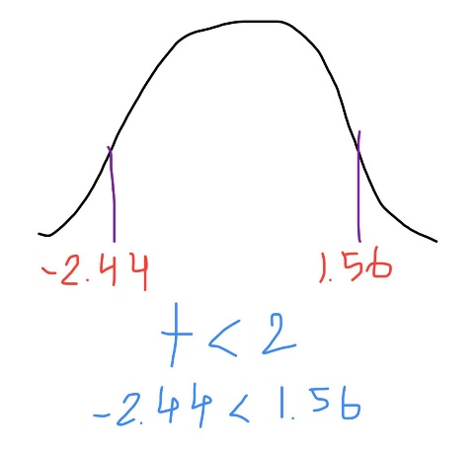

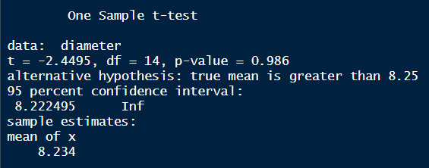4.

**Code:**

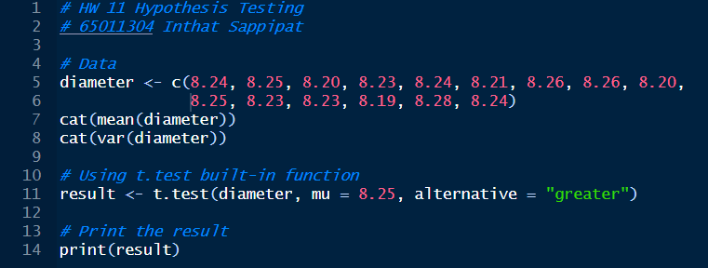

**Conclusion:**

From the experiment, I find the means whether it exceeds 8.25 mm or not using the 5 steps of the process to summarize the conclusion. Also, I have used the R built-in function which is t.test to check the result to confirm the correctness of my result using 5 steps. In my opinion, both methods lead to the same conclusion, whether I perform my own number crunching or utilize the t.test function. It appears that there isn't much of a difference in the mean diameter based on the negative t-statistic (t = -2.44).